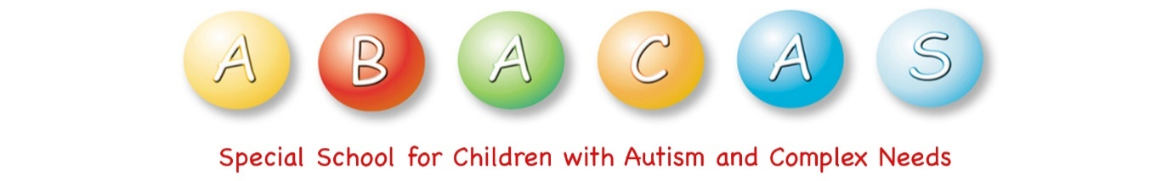
School Closures – School Year 2023/2024

School re-opens for the new year: Wednesday, 30th August 2023
October mid-term break: Closed on Monday 30th October 2023 to Friday 3rd November 2023 inclusive.

Christmas 2023: School will close on Friday, 22nd December at 12 noon.
School will re-open on Monday, 8th of January 2024.

St Bridget’s Day Holiday: Closed on Monday, 5th February 2024.

February Mid-term break: Closed on Thursday 15th February 2024 and Friday 16th February 2024 inclusive.

St. Patrick’s Day: Closed on Monday, 18th March 2024.

Easter 2024 School will close on Friday 22nd March 2021 at 12 noon.
School will re-open on Monday 8th April 2024.

May Bank Holiday: Closed from Monday 6th May to Friday 10th May 2024 inclusive.

June Bank Holiday: Closed on Monday 3rd June & Tuesday 4th June 2024 inclusive.

Summer holidays: School will close at 12 noon on Friday, 28th June 2024.

The Department of Education has indicated that there may be at least one additional closure to facilitate staff training. Holidays may be subject to change if unforeseen closures arise (snow for example). The Department of Education has indicated that if a significant number of school days are lost, schools may be required to work extra days before the Easter holiday period.

