Admission Policy of ABACAS Special School

Treepark Road, Kilnamanagh, Dublin D24 A2XF

Roll number: 20378O

School Patron: Autism Ireland

Introduction

This Admission Policy complies with the requirements of the Education Act 1998, the Education (Admission to Schools) Act 2018 and the Equal Status Act 2000. In drafting this policy, the Board of Management of the school has consulted with school staff, the school patron and with parents/guardians of children attending the school.

The policy was approved by the school patron on 12th of January 2026 It is published on the school’s website (www.abacasspecialschool.ie) and will be made available in hardcopy, on request, to any person who requests it.

The relevant dates and timelines for ABACAS Special School’s admission process are set out in the school’s Annual Admission Notice, which is published annually on the school’s website at least one week before the commencement of the admission process for the school year concerned.
This policy must be read in conjunction with the Annual Admission Notice for the school year concerned.
The Application Form for Admission is published on the school’s website and will be made available in hardcopy on request to any person who requests it.

Characteristic spirit and general objectives of the school

Our mission is to create opportunities through education, in an environment that is caring, supportive and joyful, improving the lives of children and young adults with autism and the lives of their families. Our ethos is based on the following principles:

- Child-centred
- Evidence-based intervention
- Individualised education
- Multi-denominational
- Co-educational
- Parental involvement
- Professional respect

ABACAS Special School Kilnamanagh caters for pupils aged 5 to 18 who have a diagnosis of Autism Spectrum Disorder and Complex Needs. Pupils are divided into five classes (each comprising six pupils) according to their age, skill strengths and developmental need.

Our school provides specialist curricula designed to meet the varied needs of each child and to facilitate the development of each child’s unique potential. Our school strives to maximise the learning skills, communication skills, social skills, self-care skills, self-worth and independence of our pupils by drawing on a range of evidence-based, instructional principles and methodologies in line with DES policies for children on the autism spectrum.

Admission Statement

ABACAS Special School will not discriminate in its admission of a student to the school on any of the following:

- the gender ground of the student or the applicant in respect of the student concerned,
- the civil status ground of the student or the applicant in respect of the student concerned,
- the family status ground of the student or the applicant in respect of the student concerned,
- the sexual orientation ground of the student or the applicant in respect of the student concerned,
- the religion ground of the student or the applicant in respect of the student concerned,
- the disability ground of the student or the applicant in respect of the student concerned,
- the ground of race of the student or the applicant in respect of the student concerned,
- the Traveller community ground of the student or the applicant in respect of the student concerned, or
- the ground that the student or the applicant in respect of the student concerned has special educational needs

As per section 61 (3) of the Education Act 1998, ‘civil status ground’, ‘disability ground’, ‘discriminate’, ‘family status ground’, ‘gender ground’, ‘ground of race’, ‘religion ground’, ‘sexual orientation ground’ and ‘Traveller community ground’ shall be construed in accordance with section 3 of the Equal Status Act 2000.

ABACAS Special School will cooperate with the National Council for Special Education in the performance by the Council of its functions under the Education for Persons with Special Educational Needs Act 2004 relating to the provision of education to children with special educational needs, including in particular by the provision and operation of a special class or classes when requested to do so by the Council.

ABACAS Special School will comply with any direction served on the patron or the
board, as the case may be, under section 37A and any direction served on the board
under section 67(4B) of the Education Act.

ABACAS is a school which, with the approval of the Minister for Education and Skills, provides an education exclusively for students with a category of special educational needs specified by the Minister and does not discriminate in relation to the admission of a student who does not have the category of needs specified.

Categories of Special Educational Needs catered for in the school/special class

ABACAS Special School, with the approval of the Minister for Education and Skills, provides an education exclusively for students with a diagnosis of Autism Spectrum Disorder (ASD) and Complex Needs.
Definition of an ASD diagnosis: Assessment and classification of autism or autistic spectrum disorder by a psychiatrist or clinical psychologist using DSM-IV,V or ICD-10 and /or multidisciplinary assessment of same by a professional team (including a clinical psychologist/educational psychologist).

Any child applying to the school must include the following documents (in hard copy) with their completed Application Form for Admission:
- a copy of the documented and confirmed diagnosis of ASD.
- a recent written recommendation from a certified psychologist or an assessment from a multidisciplinary team (including a clinical psychologist/educational psychologist) outlining that an Autism-specific special school is required
- A letter from the NCSE confirming that the child is known to them and that the child has the required diagnosis and recommendation for a special school dated on or before the 1st of October 2025

Any application form not accompanied by these documents will be returned to the applicant and will not be considered for admission unless the necessary documentation is submitted. If the school does not receive the necessary documentation by the closing date for applications, the application will be returned to the applicant with the advice to apply again the following year.

Admission of Students

This school shall admit each student seeking admission except where –

- the school is oversubscribed (please see section 6 below for further details)
- a parent/guardian of a student, when required by the principal in accordance with section 23(4) of the Education (Welfare) Act 2000, fails to confirm in writing that the code of behaviour of the school is acceptable to him or her and that he or she shall make all reasonable efforts to ensure compliance with such code by the student
- the applicant does not have the specified category of special educational needs provided for by this school, i.e. Autism and Complex Needs.
- the applicant has not provided a copy of the original documented and confirmed diagnosis of Autism and either a recent written recommendation from a certified psychologist or an assessment from a multidisciplinary team (including a clinical psychologist/educational psychologist) outlining that an Autism special school is required

NOTE: Applicants must be at least 5 years of age and not yet 18 years of age on 1st September of the year in which they are applying for admission.

Oversubscription

If a particular destination class is oversubscribed, the school will, when deciding on applications for admission, apply the following selection criteria in the order listed below. Parents should note that only applications which fulfil the criteria in Section 5 above will be considered for admission – whether the school or destination class is over-subscribed or not.

If a destination class is over-subscribed, qualifying applicants in the first category below will be given priority, followed by qualifying applicants in each of the subsequent categories. This process will continue to apply in turn to each criterion as places are available, until all school places are filled. Applicants who are not offered a place will be waitlisted. Where there are more applicants in a particular category than places available in a particular destination class, offers will be made based on a lottery and students will be offered a place or placed on the waiting list for that destination class based on the order they are selected in the lottery.
Category 1: Priority will be given to the age of the student most suited to the age of the class in which a space is available
Category 2: Siblings of students currently enrolled in the school providing they meet the requirements of category 1
Category 3: The child is ordinarily resident (i.e. is ordinarily resident with at least one
parent/guardian within the catchment area as defined below and as
shown in the map in Appendix 1) and has provided two proofs of address
with an Eircode from one of the areas listed.
- First priority will be given to students from Dublin 24
- Second priority will be given to students in Dublin 6W, 10, 12, 16, and 22
- Third priority will be given to students in South County Dublin
- Fourth priority will be given to students living in all other areas

NOTE: Applicants who have not submitted the required documentation outlined in Section 4 to the school by the closing date for applications will not be considered.

NOTE: The oversubscription list applies only to applications for the academic year in question. A new list will be drawn up each year. Unsuccessful applicants are therefore required to reapply with the required documentation the following year if they are to be considered for admission.

What will not be considered or taken into account

In accordance with section 62(7)(e) of the Education Act, the school will not consider or take into account any of the following in deciding on applications for admission or when placing a student on a waiting list for admission to the school:

- a student’s prior attendance at a preschool or preschool service;
- the payment of fees or contributions (howsoever described) to the school;
- a student’s academic ability, skills or aptitude; other than insofar as it is necessary in order to ascertain whether or not the student has the category of special educational needs concerned;
- the occupation, financial status, academic ability, skills or aptitude of a student’s parents/guardians;
- a requirement that a student, or his or her parents/guardians, attend an interview, open day or other meeting as a condition of admission;
- a student’s connection to the school by virtue of a member of his or her family attending or having previously attended the school, except where the student has a sibling currently enrolled in the school;
- the date and time on which an application for admission was received by the school.

This is subject to the application being received at any time during the period specified for receiving applications set out in the Annual Admission Notice of the school for the school year concerned.

Decisions on applications

Applications for a place commencing in a particular school year (e.g. September 2026) will be accepted only during the applications window referred to in the school’s annual Admissions Notice for that year. Applications received before that date will not be considered until the admissions window opens. Applications received after the closing date for applications will be treated as late applications and will most likely be wait listed as the school is heavily oversubscribed.
On application, all applicants will be assigned a destination class, depending on their age, special needs and other factors. Applicants will be aged between 5 and 17 on the 31st August of the year of admission will be assigned to the intake class. Where there are more applications than spaces in a destination class, applications will be assessed, and places offered or waitlisted based on the criteria set out in Section 6 above.

The principal of the school will make decisions in relation to the assignment of an application to a particular destination class, and the offer, refusal or wait-listing of an application. The Principal’s decision in relation to the offer, refusal or wait-listing of an application can be the subject of a request to Board to review the decision (please see Section 18 below)

All decisions on applications for admission to ABACAS will be based on the following:
• Our school’s admission policy
• The school’s annual admission notice (where applicable)
• The information provided by the applicant in the school’s official application form (and the enclosed documentation) received during the period specified in our annual admission notice for receiving applications

(Please see section 15 below in relation to applications received outside of the admissions period and section 16 below in relation to applications for places in years other than the intake group.)

Selection criteria that are not included in our school admission policy will not be used to decide on an application for a place in our school.

Notifying applicants of decisions

Applicants will be informed in writing as to the decision of the school, within the timeline outlined in the Annual Admission Notice.

If a student is not offered a place in our school, the reasons why they were not offered a place will be communicated in writing to the applicant, including, where applicable, details of the student’s ranking against the selection criteria and details of the student’s place on the oversubscription list for the school year concerned.

Applicants will be informed of the right to seek a review/right of appeal of the school’s decision (see section 18 below for further details).

Acceptance of an offer of a place by an applicant

In accepting an offer of admission from ABACAS Special School, you must indicate—
- whether or not you have accepted an offer of admission for another school or schools. If you have accepted such an offer, you must also provide details of the offer or offers concerned and
- whether or not you have applied for and are awaiting confirmation of an offer of admission from another school or schools, and if so, you must provide details of the other school or schools concerned.

Circumstances in which offers may not be made or may be withdrawn

An offer of admission may not be made or may be withdrawn by ABACAS Special School where—
- it is established that information contained in the application is false or misleading.
- an applicant fails to confirm acceptance of an offer of admission on or before the date set out in the Annual Admission Notice of the school.
- the parent/guardian of a student, when required by the principal in accordance with section 23(4) of the Education (Welfare) Act 2000, fails to confirm in writing that the code of behaviour of the school is acceptable to him or her and that he or she shall make all reasonable efforts to ensure compliance with such code by the student; or
- an applicant has failed to comply with the requirements of ‘acceptance of an offer’ as set out in section 10 above.

Sharing of data with other schools

Applicants should be aware that section 66(6) of the Education (Admission to Schools) Act 2018 allows for the sharing of certain information between schools in order to facilitate the efficient admission of students.

Annual oversubscription list

In the event of there being more applications to the school year concerned than places available, a waiting list of students whose applications for admission to ABACAS were unsuccessful due to the school being oversubscribed will be compiled and will remain valid for the school year in which admission is being sought. Placement on the waiting list of ABACAS will be for a particular destination class (as referred to above) is in the order of priority assigned to the students’ applications after the school has applied the selection criteria in accordance with this admission policy (See Section 6 above).
Offers of any subsequent places that become available for and during the school year in relation to which admission is being sought will be made to those students on the waiting list, in accordance with the order of priority in relation to which the students have been placed on the list.
Parents should note that placement on the waiting list for a particular destination class will not confer priority for that applicant for the following academic year. As the waiting list operates only for the academic year in question, parents must submit a further application for entry for the following or any subsequent academic year.

Late applications

All applications for admission received after the closing date as outlined in the annual admission notice will be considered and decided upon in accordance with our school’s admissions policy, the Education Admissions to School Act 2018 and any regulations made under that Act.

Procedures for admission of students to other years and during the school year
As noted above, all applications are assigned a destination class on receipt of the application. Available places will be offered to children who meet the criteria in section 5 above and where the destination class is over-subscribed, applicants will be offered places or waitlisted in the order of priority set out in Section 6 above. Where a late application is assigned to a destination class with an existing waiting list, that late application will be placed at the end of that waiting list. This applies to all late applications.

Declaration in relation to the non-charging of fees

This rule applies to all schools.

The board of ABACAS or any persons acting on its behalf will not charge fees for or seek payment or contributions (howsoever described) as a condition of-
- an application for admission of a student to the school, or
- the admission or continued enrolment of a student in the school.

Data protection
In accordance with our data protection policy, all application forms and supporting documentation will be retained for the duration of the school year (i.e. until the end of June in any given year), at which point they will be destroyed.

Arrangements regarding students not attending religious instruction

ABACAS special school is a non-denominational ethos school and in keeping with that children of all faiths or none are welcome to apply to the school. The school does not offer classes in any faith however on a case-by-case basis the school will facilitate the practice and preparation of first communion and confirmation for students who are of a roman catholic denomination

Reviews/appeals

Review of decisions by the board of Management
The parent/guardian of the student, or in the case of a student who has reached the age of 18 years, the student, may request the board to review a decision to refuse admission. Such requests must be made in accordance with Section 29C of the Education Act 1998.
The timeline within which such a review must be requested and the other requirements applicable to such reviews are set out in the procedures determined by the Minister under section 29B of the Education Act 1998 which are published on the website of the Department of Education and Skills.
The board will conduct such reviews in accordance with the requirements of the procedures determined under Section 29B and with section 29C of the Education Act 1998.
Note: Where an applicant has been refused admission due to the school being oversubscribed, the applicant must request a review of that decision by the Board of Management prior to making an appeal under section 29 of the Education Act 1998.
Where an applicant has been refused admission due to a reason other than the school being oversubscribed, the applicant may request a review of that decision by the Board of Management prior to making an appeal under section 29 of the Education Act 1998.

Right of appeal
Under Section 29 of the Education Act 1998, the parent/guardian of the student, or in the case of a student who has reached the age of 18 years, the student, may appeal a decision of this school to refuse admission.
An appeal may be made under Section 29 (1)(c)(i) of the Education Act 1998 where the refusal to admit was due to the school being oversubscribed.
An appeal may be made under Section 29 (1)(c)(ii) of the Education Act 1998 where the refusal to admit was due a reason other than the school being oversubscribed.
Where an applicant has been refused admission due to the school being oversubscribed, the applicant must request a review of that decision by the Board of Management prior to making an appeal under section 29 of the Education Act 1998. (see Review of decisions by the Board of Management)
Where an applicant has been refused admission due to a reason other than the school being oversubscribed, the applicant may request a review of that decision by the Board of Management prior to making an appeal under section 29 of the Education Act 1998. (see Review of decisions by the Board of Management)
Appeals under Section 29 of the Education Act 1998 will be considered and determined by an independent appeals committee appointed by the Minister for Education and Skills.
The timeline within which such an appeal must be made and the other requirements applicable to such appeals are set out in the procedures determined by the Minister under section 29B of the Education Act 1998 which are published on the website of the Department of Education and Skills.

Progression at the school

Some children’s needs may change overtime and exceed what the school setting can cater for. If a psychologist, psychiatrist or the Principal confirm that another school placement would better meet the needs of the child, a recommendation will be made that the child is supported to seek a more appropriate school placement. This will be supported by the school and relevant professionals.
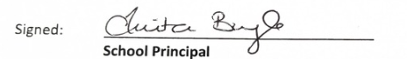

Date: 19.01.2026
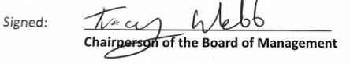
Date: 19.01.2026

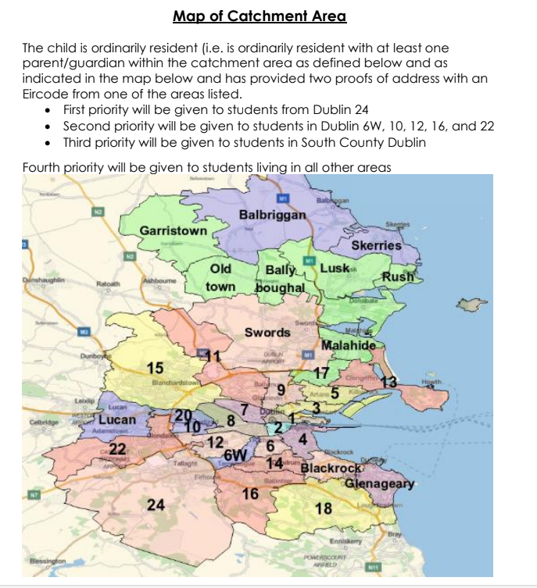
Appendix 1

